Mpho Edward Makata
NET512 Practical week 1

Topology
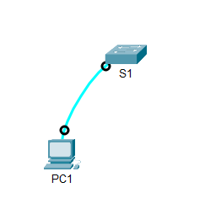

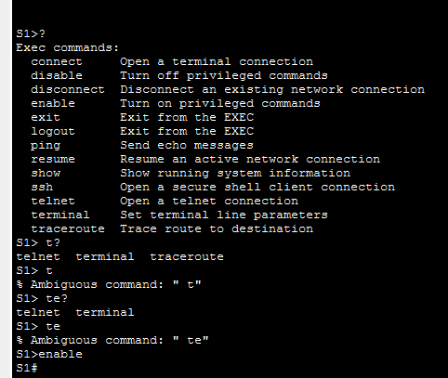

Which command begins with the letter ‘C’?
Connect – Open a terminal connection

Part 2 Exec Modes

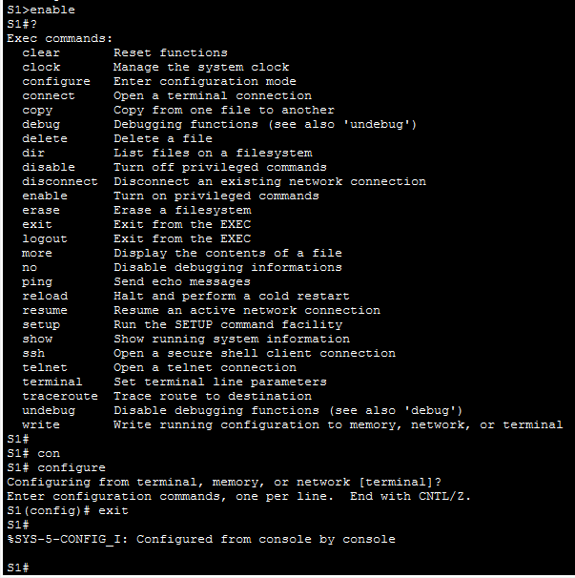

2 C. There are 5 commands that starts with a C

Part 3 Set the clock
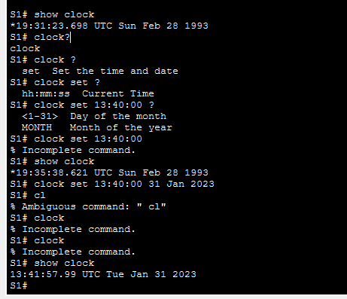
3 A. 1993
B. clock
C. hh:mm:ss Current Time
D. *19:35:38.621 UTC Sun Feb 28 1993

